Parth Babbar

Compliance and Regulatory Affairs in Banking Operations

**Introduction:**

Compliance and Regulatory Affairs in banking refers to following appropriate rules, regulations, standards, and specifications to guarantee that the bank works within the framework established by financial regulators. This approach upholds ethical norms while safeguarding the interests of clients, stakeholders, and the financial system. Compliance and regulatory affairs cover a wide variety of operations, including as monitoring and managing legal risks, developing internal controls, and maintaining up to speed on regulatory developments. Banks may avoid legal fines, preserve operational integrity, and gain the trust and credibility of their clients and the larger financial community by using these strategies.

**Importance of Compliance :**

1. **Anti-Money Laundering (AML) and Counter-Terrorism Financing (CTF):** It entails following rules and regulations to uphold ethical standards and safeguard stakeholders. Monitor legal risks, create internal controls, and file Suspicious Activity Reports (SARs) and Currency Transaction Reports (CTRs). These measures assist banks in avoiding penalties while also building confidence with customers and the financial community.
2. **Know Your Customer(KYC):** Customer Identification Programmes (CIP) and Customer Due Diligence (CDD) are examples of banking compliance measures designed to uphold ethical standards and safeguard stakeholders. These programmes assure regulatory compliance and assist banks in establishing confidence with clients and regulators.
3. **Data Protection & Privacy:** The Gramm-Leach-Bliley Act (GLBA) requires financial institutions to securely handle and disclose consumers' financial information. Meanwhile, the California Consumer Privacy Act (CCPA) grants California citizens access to their personal data kept by corporations, improving privacy regulations and giving consumers more control over their information.
4. **Consumer Protection:** Compliance with TILA, FCRA, and ECOA regulations guarantees that consumers are treated fairly and are protected from fraud and discrimination throughout credit transactions. These laws require explicit disclosure of credit conditions (TILA), restrict credit information use (FCRA), and ban discriminatory practices (ECOA), so enhancing transparency and consumer rights in finance.

**Regulatory Bodies:**

1. The Federal Reserve System (FED) oversees and supervises banks to maintain their safety and stability.  
   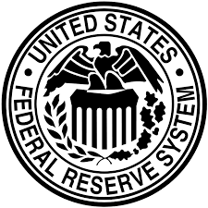
2. The Office of the Comptroller of the Currency (OCC) regulates and supervises national banks and federal savings institutions.  
   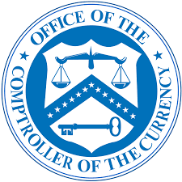
3. The Federal Deposit Insurance Corporation (FDIC) insures deposits and regulates banks to protect their viability.  
   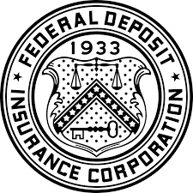
4. Consumer Financial Protection Bureau (CFPB) oversees consumer protection in the financial industry.  
   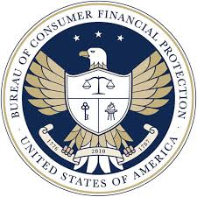

**Regulations:**

1. Dodd-Frank The Wall Street Reform and Consumer Protection Act of 2010 was enacted to counteract the excessive risk-taking that caused the 2008 financial crisis. It contains the Volcker Rule, which bans banks' proprietary trading.  
   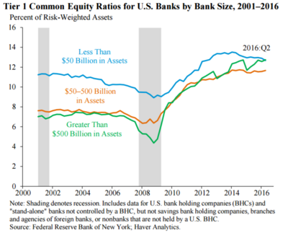
2. The Bank Secrecy Act (BSA) requires banks to help government authorities in identifying and combating money laundering.
3. Anti-Money Laundering (AML) Regulations implements steps to prevent, identify, and report money laundering activity.
4. The Sarbanes-Oxley Act (SOX) establishes higher requirements for all public business boards, management, and public accounting firms in the United States.
5. The Gramm-Leach-Bliley Act (GLBA) requires financial organisations to disclose how they share and safeguard their customers' private information.

**Risks:**

1. **Regulatory Changes:** Constantly changing rules necessitate ongoing monitoring and modifications to compliance programmes.
2. **Business Risks:** Inefficient compliance processes might cause business interruptions.
3. **Financial Risks:** Noncompliance might lead to significant penalties and legal fees.
4. **Reputational Risks:** Publicised compliance lapses can seriously harm a bank's reputation.
5. **Cybersecurity Risks:** The growing reliance on digital operations raises the danger of data breaches.

**Case Studies and Statistics on Regulatory Compliance in Banking:**

**Case Studies:**

1. **Wells Fargo Scandal(2016):** Wells Fargo workers have been accused of creating 1.5 million unauthorised bank accounts and 565,000 credit card accounts. The Justice Department and the Securities and Exchange Commission fined Wells Fargo $3 billion in February 2020 for the bogus account scam. In September 2021, the bank agreed to pay the Justice Department $72.6 million to resolve claims of overcharging currency exchange clients. These occurrences underscore the banking sector's continued regulatory issues as well as initiatives to defend customer rights.
2. **JP Morgan Chase(2020):** JPMorgan Chase paid a $920 million punishment for market manipulation in 2020, highlighting regulatory issues in the financial sector as well as the need of compliance and ethical standards.

**Statistics:**

1. **Fines & Penalties:** In 2020 alone, US banks paid more than $11.4 billion in fines and penalties for noncompliance concerns. From 2008 to 2023, banks faced a record $321 billion in fines for compliance lapses, illustrating the financial sector's ongoing issues with regulatory adherence.  
   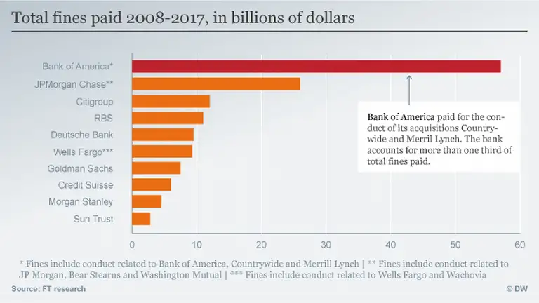
2. **Compliance Cost:** According to a PwC analysis, compliance expenses for banks in the United States increased by 15% each year between 2016 and 2020. By 2023, global spending on financial institution compliance will reach nearly $270 billion per year, demonstrating the considerable investment required to satisfy severe regulatory standards throughout the world.

**Conclusion:**

Compliance and regulatory affairs in banking operations are crucial to ensuring the financial system's stability and integrity. As rules develop, banks must constantly adjust their compliance strategies, employing technology to efficiently manage risks and maintain regulatory compliance. Compliance investments not only avoid legal fines, but also foster confidence among clients and stakeholders, ensuring the bank's reputation and operational sustainability.